**VISVESVARAYA TECHNOLOGICAL UNIVERSITY BELAGAVI-590018**



**AMINI PROJECT REPORT ON**

**CAR RENTAL SYSTEM**

**BY**

**SWASTHIK JAIN P M VARSHITH V HEGDE**

**(4MT19CS166) (4MT19CS174)**

*In the partial fulfillment of the requirement for 5th semester*

**DBMS LABORATORY WITH MINI PROJECT**

***Under the guidance of***

**Mr. Sunil Kumar S Ms. Jyothi GN**

**Senior Assistant Professor Assistant Professor**



**Department of Computer Science and Engineering**

**(Accredited by NBA)**

**MANGALORE INSTITUTE OF TECHNOLOGY & ENGINEERING**

**Badaga, Mijar, Moodbidri-574225**

***2021-2022***

 **MANGALORE INSTITUTE OF TECHNOLOGY & ENGI NEERING**

**(An ISO 9001:2015 Certified Institution, Accredited by NAAC)**

**Badaga, Mijar, Moodbidri-574225**

**DEPARTMENT OF COMPUTER SCIENCE AND ENGINEERING**

**(Accredited by NBA)**

**CERTIFICATE**

This is to certify that Mr **SWASTHIK JAIN P M(4MT19CS166)** has satisfactorily completed the mini project entitled “**CAR RENTAL SYSTEM”** for the **DBMS Laboratory with mini project(18CSL58)**lab as prescribed by the VTU for 5th semester B.E. Computer Science and Engineering branch for the academic year 2021 – 2022.

|  |  |  |
| --- | --- | --- |
| **…………………………** | **…………………………** | **…………………………** |
| **Mr. Sunil Kumar S** | **Ms. Jyothi GN** | **Mr. Ravinarayana B** |
| **Senior Assistant Professor** | **Assistant Professor** | **Associate Professor & HOD** |
| **MITE, Moodabidri** | **MITE, Moodabidri** | **MITE, Moodabidri** |

**Signature of the Examiners**

**1. …………………………..**

**2. …………………………..**

**ABSTRCT**

This project is designed so as to be used by Car Rental Company specializing in renting cars to customers. It is an online system through which customers can view available cars, register and book car.

We developed this project to book a car on rent at the fare charges. In present system all booking work done manually and it takes very hard work to maintain the information of booking and cars. if you want to find which vehicle is available for booking then it take a lot of time. It only makes the process more difficult and hard. This aim of the project is to automate the work performed in the car rental management system like records of cab, cabs available for booking, rental charges for cars, store records of the customer.

CaRs is a car booking software that provides a complete solution to all your day-to-day car booking office running needs. This system helps you to keep the information of customer online. You can check your customer information any time by using this system. Online car rental management system is a unique and innovative product. Based on this information you can take decision regarding your business development.

**ACKNOWLEDGEMENT**

The successful completion of any significant task is the outcome of invaluable aggregate combination of different people in radial direction explicitly and implicitly. We would therefore take opportunity to thank and express our gratitude to all those without whom the completion of project would not be possible.

We express our thanks to **Mr. Sunil Kumar S, Senior Assistant Professor and Ms. Jyothi G N, Assistant Professor** Department of Computer Science and Engineering for having provided all the facilities that helped us in timely completion of this report.

We express our sincere gratitude to **Mr. Ravinarayana B, Associate Professor, Head of the Department, Computer Science and Engineering** for his support and guidance.

We would like to thank **Dr. Ganesh Prasad**, **Principal,** **Mangalore Institute of Technology and Engineering, Moodabidri** for his support and encouragement.

I express my sincere gratitude to our institution and management for providing us with good infrastructure, laboratory facilities, qualified and inspiring staffs, and whose guidance was of immense help in completion of this seminar successfully.

**SWASTHIK JAIN P M 4MT19CS166**

**VARSHITH V HEGDE 4MT19CS174**

**LIST OF FIGURES**

|  |  |  |
| --- | --- | --- |
| **Sl No** | **TITLE** | **PAGE NO.** |

**3.1 ER Diagram 7**

**3.2 Schema Diagram** 9

**3.3 Flowchart** 11

**3.4 Block diagram** 13

**TABLE OF CONTENTS**

1

**Abstract…………………………………………………………………………………………………....**

2

**Acknowledgement…**

|  |  |  |
| --- | --- | --- |
| **CHAPTER** | **CONTENT** | **PAGE NO** |
| **1** | **Introduction** | 1-3 |
| **2** | **Analysis and Requirement Specification** 4-5 | |
| **3** | **System Design** | 6-14 |
| **4** | **Implementation** | 15-18 |
| **5** | **Testing** | 19-21 |
| **6** | **Snapshots** | 22-31 |
| **7** | **Conclusion** | 32 |
|  | **References** | 33 |

**Chapter 1**

**INTRODUCTION**

Transport facility is a matter of headache for those people who do not have any personal transport . On occasions like Wedding, Vacation, house shifting and tour on many other situations they feel the necessity of a vehicle to sort out the problems. So if it is possible to design or develop a web based application for availing transport whenever and wherever possible, then it will be beneficial for both renter and transport provider. Now a days, by some clicks only, we can get whatever you want at home.We already know about the online shopping, e-banking etc.

A vehicle rental office is an organization that rents cars for a period of time, for the most part lasting from a few days to half a month. This is routinely resolved with various neighborhood offices (which permit a client to reestablish a vehicle to a substitute region), and fundamentally to railroad stations, air terminals, or involved city territory found close and frequently enhanced by a website permitted on web reservations. Vehicle rental organizations essentially serve individuals who need a transitory vehicle, for example, individuals who don't claim their own vehicle, who are away, or damage or damage owners of vehicles who are estimating fix or protection remuneration. Close by the fundamental rental of a vehicle, vehicle rental organizations regularly additionally offer additional items, for example, protection , particularly for enormous, premium, and little vehicle rental business. Presently a-days, by certain snaps no one but, we can get anything you desire at home. We certainly consider online shopping, e-banking, etc. Correspondingly, The Car Rental System is the online office to book vehicles online inside hardly any snaps in a manner of speaking. A couple of individuals can't remain to have a vehicle, for those people this system ends up being outstandingly helpful. Booking should be possible by means of network access as it were. This undertaking navigates plenty of territories going from business idea to registering field and required to play out a few explore to have the option to accomplish the venture goals. The zone covers include:

Vehicle rental industry: This makes sure to focus on how the vehicle rental business is being done, the procedure notwithstanding, and probabilities that represent advancement.

For improving the site, PHP Technology is utilized.

General customer just as the organization's people will have the option to utilize the framework appropriately.

Web-standing include that the frame work will be accessible for get to all day , normal day aside from when there is a fleeting server issue that is needy upon to be irrelevant.

The product Car Rental System have a incredibly simple to understand edge. Along these lines, the representatives will feel exceptionally simple to take a shot at it. The information new information can be included or an existed information can be altered or erased too by Admin and also by Customer. Hence, there is no postponement in the accessibility of any data, whatever required, can be caught rapidly and no problem at all.

The Car Rental System is the online facility to book cars online within few clicks only. Some people can not afford to have a car, for those people this system becomes very helpful. This system includes various cars, as per the customer order and comfort, it place the order and deliver the car as per the location within the area. For travelling a long distance, booking can be done via internet service only.

**1.1 Problem statement:**

A car rental is a vehicle that can be used temporarily for a fee during a specified period. Getting a rental car helps people get around despite the fact they do not have access to their own personal vehicle or don't own a vehicle at all. The individual who needs a car must contact a rental car company and contract out for a vehicle. This system increases customer retention and simplify vehicle and staff management.

**1.2 SQL :**

MySQL ("My S-Q-L", officially, but also called "My Sequel") is (as of July 2013) the world's second most widely used open-source relational database management system (RDBMS). The SQL phrase stands for Structured Query Language. The MySQL development project has made its source code available under the terms of the GNU General Public License, as well as under a variety of proprietary agreements. MySQL was owned and sponsored by a single for-profit firm, the Swedish company MySQL AB, now owned by Oracle Corporation. MySQL is a popular choice of database for use in web applications, and is a central component of the widely used LAMP open source web application software stack (and other 'AMP' stacks). LAMP is an acronym for "Linux, Apache, MySQL, PHP." Free-software-open source projects that require a full-featured database management system often use MySQL.

**1.3 PHP :**

PHP is a server-side scripting language designed for web development but also used as a general-purpose programming language. PHP is now installed on more than 244 million websites and 2.1 million web servers. Originally created by Rasmus Lerdorf in 1995, the reference implementation of PHP is now produced by The PHP Group. While PHP originally stood for Personal Home Page, it now stands for PHP: Hyper Text Preprocess .PHP code is interpreted by a webserver with a PHP processor module, which generates the resulting web page PHP commands can be embedded directly into an HTML source document rather than calling an external file to process data. It has also evolved to include a command-line interface capability and can be used in standalone graphical applications. PHP is free software released under the PHP License. PHP can be deployed on most web servers and also as a standalone shell on almost every operating system and platform, free of charge.

**1.4 HTML5 :**

HTML or Hyper Text Markup Language is the main markup language for creating web pages and other information that can be displayed in a web browser.HTML is written in the form of HTML elements consisting of tags enclosed in angle brackets (like <html>), within the web page content. HTML tags most commonly come in pairs like <h1> and </h1>, although some tags represent empty elements and so are unpaired, for example <img>. The first tag in a pair is the start tag, and the second tag is the end tag (they are also called opening tags and closing tags).In between these tags web designers can add text, further tags, comments and other types of text-based content. The purpose of a web browser is to read HTML documents and compose them into visible or audible web pages. The browser does not display the HTML tags, but uses the tags to interpret the content of the page.HTML elements form the building blocks of all websites. It allows images and objects to be embedded and can be used to create interactive forms. It provides a means to create structured documents by denoting structural semantics for text such as headings, paragraphs, lists,links, quotes and other items. It can embed scripts written in languages such as JavaScript which affect the behavior of HTML web pages.

**1.5 CSS3:**

Cascading Style Sheets (CSS) is a style sheet language used for describing the look and formatting of a document written in a markup language. While most often used to style web pages and interfaces written in HTML and XHTML, the language can be applied to any kind of XML document, including plain XML, SVG and XUL. CSS is a cornerstone specification of the web and almost all web pages use CSS style sheets to describe their presentation.CSS is designed primarily to enable the separation of document content from document presentation, including elements such as the layout, colors, and fonts. This separation can improve content accessibility, provide more flexibility and control in the specification of presentation characteristics, enable multiple pages to share formatting, and reduce complexity and repetition in the structural content (such as by allowing for table less web design).CSS can also allow the same markup page to be presented in different styles for different rendering methods, such as on-screen, in print, by voice (when read out by a speech-based browser or screen reader) and on Braille-based, tactile devices. It can also be used to allow the web page to display differently depending on the screen size or device on which it is being viewed. While the author of a document typically links that document to a CSS file, readers can use a different style sheet, perhaps one on their own computer, to override the one the author has specified. However if the author or the reader did not link the document to a specific style sheet the default style of the browser will be applied.CSS specifies a priority scheme to determine which style rules apply if more than one rule matches against a particular element. In this so-called cascade, priorities or weights are calculated and assigned to rules, so that the results are predictable.

**1.6 JAVASCRIPT**:

JavaScript(JS) is a dynamic computer programming language. It is most commonly used as part of web browsers, whose implementations allow client side scripts to interact with the user, control the browser, communicate asynchronously, and alter the document content that is displayed. It is also being used in server-side programming, game development and the creation of desktop and mobile applications. JavaScript is a prototype-based scripting language with dynamic typing and has first-class functions. Its syntax was influenced by C. JavaScript copies many names and naming conventions from Java, but the two languages are otherwise unrelated and have very different semantics. The key design principles within JavaScript are taken from the Self and Scheme programming languages. It is a multiparadigm language, supporting object-oriented, imperative, and functional programming styles. The application of JavaScript to use outside of web pages—for example, in PDF documents, site-specific browsers, and desktop widgets—is also significant. Newer and faster JavaScript VMs and platforms built upon them (notably Node.js) have also increased the popularity of JavaScript for server-side web application.

**1.7 Apache Web Server :**

In this project apache server is used to parse and execute PHP pages, before deploying websites on the server, the website should be tested at the developer side to get a feel of how the website will work on actual server. Therefore apache server is like a local server on the developer side, apache server should be informed about the environment on which it should work. In our project apache server is configured to work with PHP, in this way all the PHP pages are parsed and executed by the server. When apache is installed on the system ,then it services is controlled by apache service monitor.

**Chapter 2**

**ANALYSIS AND REQUIREMENT SPECIFICATION**

**2.1 Objectives :**

* To produce a web-based system that allow customer to register and reserve car online and for the company to effectively manage their car rental business.
* To ease customer’s task whenever they need to rent a car.

**2.2 Scope :**

This project traverses a lot of areas ranging from business concept to computing field, and required to perform several researches to be able to achieve the project objectives.

The area covers include:

* Car rental industry: This includes study on how the car rental business is being done, process involved and opportunity that exist for improvement.
* PHP Technology used for the development of the application.
* General customers as well as the company’s staff will be able to use the system effectively.
* Web-platform means that the system will be available for access 24/7 except when there is a temporary server issue which is expected to be minimal.

**2.3 Functional Requirements :**

Requirement analysis is a software engineering technique that is composed of the various tasks that determine the needs or conditions that are to be met for a new or altered product, taking into consideration the possible conflicting requirements of the various users.

Functional requirements are those requirements that are used to illustrate the internal working nature of the system, the description of the system, and explanation of each subsystem.

It consists of what task the system should perform, the processes involved, which data should the system holds and the interfaces with the user.

The functional requirements identified are:

1. Customer’s registration: The system should allow new users to register online and generate membership card.
2. Online reservation of cars: Customers should be able to use the system to make booking and online reservation.
3. Automatic update to database once reservation is made or new customer registered: Whenever there’s new reservation or new registration, the system should be able update the database without any additional efforts from the admin.
4. Feedbacks to customers: It should provide means for customers to leave feedback

**2.4 Non-Functional Requirements :**

It describes aspects of the system that are concerned with how the system provides the functional requirements.

They are:

1. Security: The subsystem should provide a high level of security and integrity of the data held by the system, only authorized personnel of the company can gain access to the company’s secured page on the system; and only users with valid password and username can login to view user’s page.
2. Performance and Response time: The system should have high performance rate when executing user’s input and should be able to provide feedback or response within a short time span usually 50 seconds for highly complicated task and 20 to 25 seconds for less complicated task.
3. Error handling: Error should be considerably minimized and an appropriate error message that guides the user to recover from an error should be provided. Validation of user’s input is highly essential. Also the standard time taken to recover from an error should be 15 to 20 seconds.
4. Availability: This system should always be available for access at 24 hours, 7 days a week. Also in the occurrence of any major system malfunctioning, the system should be available in 1 to 2 working days, so that the business process is not severely affected.
5. Ease of use: Considered the level of knowledge possessed by the users of this system, a simple but quality user interface should be developed to make it easy to understand and required less training.

**Hardware Requirements:**

CPU Type : Pentium dual or above

RAM : 2 GB or above

Display Type : VGA

Hard Disk Drive : 20 GB or greater

Printer : Any Printer Supported by the OS

**Software Requirements :**

Operating System : WINDOWS 7 or higher

Front End : PHP, HTML5,CSS3,JAVA SCRIPT

Back End : MYSQL SERVER

**Chapter 3**

**SYSTEM DESIGN**

System Design process partitions the system into subsystems based on the requirements. It establishes overall system architecture and is concerned with identifying various components, specifying relationships among components, specifying software structure, maintaining a record of design decisions and providing a blue print for the implementation phase [6]. Design consists of architecture design and detailed design is concerned with the details of how to package processing modules and how to implement the processing algorithms, data structures and interconnections among modules and data structures.

**3.1 ER Diagram**

**3.2 Schema Diagram**

**3.2.1 Description of the Tables.**

**3.3 Flowchart**

**3.4 Block Diagram**

**3.1 ER DIAGRAM:** An Entity Relationship (ER) Diagram is a type of flow chart that illustrate how “entities” such as objects or concepts relate to each other within a system.

M

N

M

M

1

1

N

N

1

N

GIVES

DOES

RENTS

APPROVE

HAS

PAYMENT

BOOKING

FEED BACK

ADMIN

USER

CAR

ER DIAGRAM OF CAR RENTAL SYSTEM

**ASSUMPTION MADE:**

1. Many user can do many booking ( thus M:N ).
2. Many user can give many feedback ( thus M:N )
3. One admin can approve many bookings ( thus 1:N )
4. One booking has one payment ( Maximum 1 thus 1:1 )
5. Many cars has many bookings(thus M:N )

**3.2 SCHEMA DIAGRAM:** A schema diagram is a diagram which contains entities and the attributes that will define that schema.

ADMIN

|  |  |
| --- | --- |
| ADMIN_ID | ADMIN_PASSWORD |

CAR

|  |  |  |  |  |  |  |
| --- | --- | --- | --- | --- | --- | --- |
| CAR_ID | CAR_NAME | CAPACITY | AVAILABLE | PRICE | FUEL_TYPE | CAR_IMG |

USER

|  |  |  |  |  |  |  |
| --- | --- | --- | --- | --- | --- | --- |
| FNAME | LNAME | EMAIL | PASSWORD | GENDER | PHONE | LIC_NUMBER |

BOOKING

|  |  |  |  |  |  |  |  |
| --- | --- | --- | --- | --- | --- | --- | --- |
| BOOK_ID | BOOK_PLACE | BOOK_DATE | PRICE | DESTINATION | RETURN_DATE | CAR_ID | EMAIL |

PAYMENT

|  |  |  |  |  |  |
| --- | --- | --- | --- | --- | --- |
| PAYMENT_ID | CARD_NO | EXP_DATE | CVV | PRICE | BOOK_ID |

FEEDBACK

|  |  |  |
| --- | --- | --- |
| FED_ID | COMMENT | EMAIL |

SCHEMA DIAGRAM OF CAR RENTAL SYSTEM

**3.2.1 DESCRIPTION OF TABLES:**

The database consist of six tables:

1. ADMIN: It stores the details of admin.
2. ADMIN_ID : User name of the admin.
3. ADMIN_PASSWORD: Password of the Admin.
4. CAR: It gives the details about the car.
5. CAR_ID : Id given to car done by auto increment.
6. CAR_NAME: Name of the car.
7. CAPACITY: Seat capacity.
8. AVAILABLE: Availability of car.
9. PRICE: Price of the car.
10. FUEL_TYPE: Car fuel type.
11. CAR_IMG: Image of car.
12. USER: It stores the details of user.
13. FNAME: first name of user.
14. LNAME: Last name of user.
15. EMAIL: Email of user.
16. PASSWORD: Password of user.
17. GENDER: Gender of user.
18. PHONE: Phone number of user.
19. LIC_NUMBER: License no of user.
20. BOOKING: It give the booking details for user.
21. BOOK_ID: Booking id done by auto increment.
22. BOOK_PLACE: Place of booking.
23. BOOK_DATE: Date of booking.
24. PRICE: Price of car.
25. DESTINATION: Destination.
26. RETURN_DATE: Return date.
27. CAR_ID: Id given to car and foreign key car associated with booking.
28. EMAIL: Email of user and foreign key of user associated with booking .
29. PAYMENT: It provides payment option for users.
30. PAYMENT_ID: Id given to payment and done by auto increment.
31. CARD_NO: Card number.
32. EXP_DATE: Expiry Date of card.
33. CVV: Cvv of card.
34. PRICE: Price of car.
35. BOOK_ID: Id given to booking and foreign key of booking associated with payment.
36. FEEDBACK: It gives the space for user to enter their feedback about their experience.
37. FEED_ID: id given to the feedback done by auto increment.
38. COMMENT: Message about their experience.
39. EMAIL: Email of user and foreign key of user associated with feedback.

**3.3 FLOW CHART :**A flow chart is a type of diagram that represents a work flow or process.

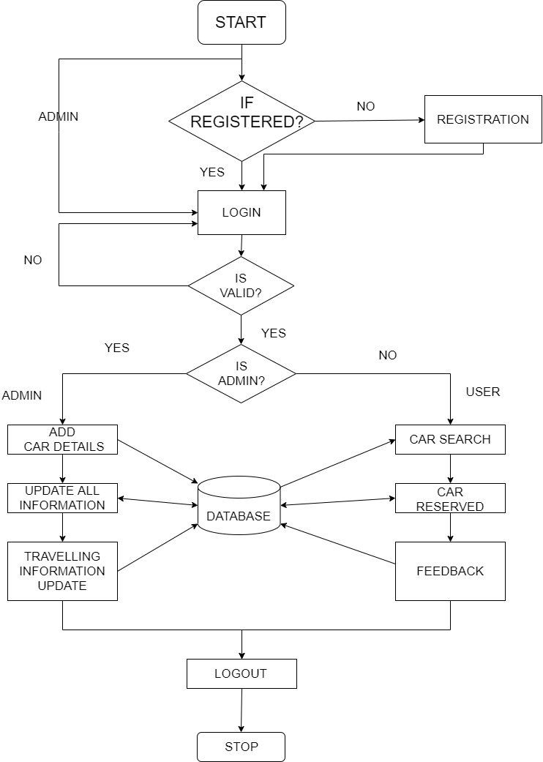

FLOW CHART OF CAR RENTAL SYSTEM

In this Flow Chart User and Admin are the two entity sets.

USER:

If the user is registered t hen login using appropriate Email and Password .

If the customer is not registered he has to register by providing valid details and then login by providing appropriate details.

After login User can perform following functions.

Functions of Customer:

* View Car.
* Make Booking.
* Make Payment.
* Check Booking Status
* Give Feedback.

ADMIN:

Admin can login by providing appropriate Admin_id and Password.

After login Admin can perform following functions.

Functions of Admin:

* Can do vehicle management.
* Add car.
* Delete car.
* Approve booking.
* Delete customer.
* View feedback.

Both can logout from the website by clicking logout button.

**3.6 BLOCK DIAGRAM:** A block diagram is a graphical representation of a system-it provides functional view of a system.

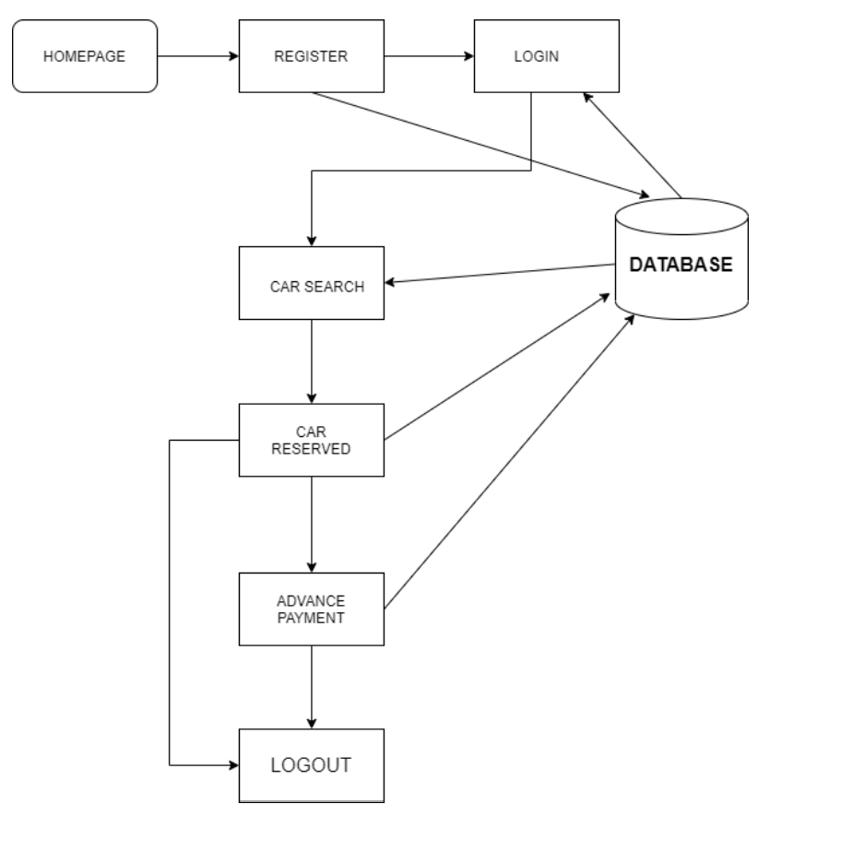BLOCK DIAGRAM OF CAR RENTAL SYSTEM

Here User need first open the website then he has register by providing appropriate details then he has to login by providing Email and Password.

After registering has a user they can access the facilities of the website.

They can see car list in the Home page and they can select their desired car for rent.

After selecting desired car it redirects to the Booking page here they need to fill the valid details in the booking page to book the car.

After booking the car it redirects to the payment page here they need to fill the valid payment card details in order to pay for the booked rent car.

After payment it redirects to the Home page .In home Page they have option called booking status there they can check the booking status .

They can also give the feed back of their experience after using rent car.

They can logout by pressing logout button.

**Chapter 4**

**IMPLEMENTATION**

PHP: Hypertext Pre-processor (or simply PHP) is a server-side scripting language designed for web development, and also used as a general-purpose programming language. PHP code may be embedded into HTML code, or it can be used in combination with various web template systems, web content management systems, and web frameworks. PHP code is usually processed by a PHP interpreter implemented as a module in the web server or as a Common Gateway Interface (CGI) executable. The web server combines the results of the interpreted and executed PHP code, which may be any type of data, including images, with the generated web page. PHP code may also be executed with a command-line interface (CLI) and can be used to implement standalone graphical applications.

This project uses HTML as front-end tool. Hypertext Mark-up Language (HTML) is the standard mark-up language for creating web pages and web applications. With Cascading Style Sheets (CSS) and JavaScript, it forms a triad of cornerstone technologies for the world wide web. Web browser receive HTML documents from a web server or from local storage and render the documents into multimedia web pages.HTML describes the structure of a web page semantically and originally included cues for the appearance of the document.HTML elements are the building blocks of HTML pages. With HTML constructs, images and other objects such as interactive forms may be embedded into the rendered page.HTML provides a means to create structured documents by structural semantics for text such as headings, paragraphs, lists, links, quotes and other items.HTML elements are delineated by tags, written using angle brackets. Browsers do not display the HTML tags, but use them to interrupt the content of the page.

**4.1 Code Snippet:**

Figure 4.1.1 Code Snippet of Connection Module

<?php

    mysqli_report(MYSQLI_REPORT_ERROR | MYSQLI_REPORT_STRICT);

    $con = mysqli_connect('localhost','root','','carproject');

    if(!$con)

    {

        echo 'please check your Database connection';

    }

?>

Some Of Other Back End Codes:

Figure 4.1.2 Code Snippet of Delete Car

<?php

require_once('connection.php');

$carid=$_GET['id'];

$sql="DELETE from cars where CAR_ID=$carid";

$result=mysqli_query($con,$sql);

echo '<script>alert("CAR DELETED SUCCESFULLY")</script>';

echo '<script> window.location.href = "adminvehicle.php";</script>';

?>

Figure 4.1.3 Code Snippet of Uploading Car Image

<?php

if(isset($_POST['addcar']) ){

    require_once('connection.php');

   echo "<prev>";

   print_r($_FILES['image']);

   echo "</prev>";

   $img_name= $_FILES['image']['name'];

   $tmp_name= $_FILES['image']['tmp_name'];

   $error= $_FILES['image']['error'];

    if($error === 0){

        $img_ex = pathinfo($img_name,PATHINFO_EXTENSION);

        $img_ex_lc= strtolower($img_ex);

        $allowed_exs = array("jpg","jpeg","png","webp","svg");

        if(in_array($img_ex_lc,$allowed_exs)){

            $new_img_name=uniqid("IMG-",true).'.'.$img_ex_lc;

            $img_upload_path='images/'.$new_img_name;

            move_uploaded_file($tmp_name,$img_upload_path);

                $carname=mysqli_real_escape_string($con,$_POST['carname']);

                $ftype=mysqli_real_escape_string($con,$_POST['ftype']);

                $capacity=mysqli_real_escape_string($con,$_POST['capacity']);

                $price=mysqli_real_escape_string($con,$_POST['price']);

                $available="Y";

                $query="INSERT INTO cars(CAR_NAME,FUEL_TYPE,CAPACITY,PRICE,CAR_IMG,AVAILABLE) values('$carname','$ftype',$capacity,$price,'$new_img_name','$available')";

                $res=mysqli_query($con,$query);

                if($res){

                    echo '<script>alert("New Car Added Successfully!!")</script>';

                    echo '<script> window.location.href = "adminvehicle.php";</script>';                }

}else{

            $em = "You cant upload files of this type";

            header("Location: addcar.php?error=$em");

  }

}

    else{

        $em="unknown error occured";

        header("Location: addcar.php?error=$em");

}}

else{

    echo "false";}

?>

Figure 4.1.4 Code Snippet of Approve

<?php

require_once('connection.php');

$bookid=$_GET['id'];

$sql="SELECT *from booking where BOOK_Id=$bookid";

$result=mysqli_query($con,$sql);

$res = mysqli_fetch_assoc($result);

$car_id=$res['CAR_ID'];

$sql2="SELECT *from cars where CAR_ID=$car_id";

$carres=mysqli_query($con,$sql2);

$carresult = mysqli_fetch_assoc($carres);

if($carresult['AVAILABLE']=='Y')

{

if($res['BOOK_STATUS']=='APPROVED')

{

    echo '<script>alert("ALREADY APPROVED")</script>';

    echo '<script> window.location.href = "adminbook.php";</script>';

}

else{

    $query="UPDATE booking set  BOOK_STATUS='APPROVED' where BOOK_ID=$bookid";

    $queryy=mysqli_query($con,$query);

    $sql2="UPDATE cars set AVAILABLE='N' where CAR_ID=$res[CAR_ID]";

    $query2=mysqli_query($con,$sql2);

    echo '<script>alert("APPROVED SUCCESSFULLY")</script>';

    echo '<script> window.location.href = "adminbook.php";</script>';

}

}

else{

    echo '<script>alert("CAR IS NOT AVAILABLE")</script>';

    echo '<script> window.location.href = "adminbook.php";</script>';

}

?>

**Chapter 5**

**TESTING**

Software testing is the process of used to identify the correctness, security, completeness and quality of developed computer software. This includes the process of executing the program or applications with the intent of finding errors. An individual unit, functions or procedures of developed project is verified and validated and these units are fit for use.

**5.1 Testing process**

Best testing process is to test each subsystem separately, as we have done in project. Best done during implementation. Best done after small sub-steps of the implementation rather than large chunks. Once each lowest level unit has been tested, units are combined with related units and retested in combination. This proceeds hierarchically bottom-up until the entire system is tested as a whole. Typical levels of testing:

* Module- package, abstract data type, class
* Sub-system- collection of related modules, cluster of classes, method-message paths
* Acceptance testing- whole system with real data (involve customer, user, etc)

Alpha testing is acceptance testing with a single client (common for bespoke systems).

Beta testing involves distributing system to potential customers to use and provide feedback. In this project, beta testing has been followed. This exposes system to situations and errors that might not be anticipated by us.

**5.1.1 Unit testing**

Unit testing is the process of testing individual software components unit or modules. Since it needs the detailed knowledge of the internal program design and code this task is done by the programmer and not by testers.

**5.1.2 Integration Testing**

Integration testing is another aspect of testing that is generally done in order to uncover errors associated with the flow of data across interfaces. The unit-tested modules are grouped together and tested in small segment, which makes it easier to isolate and correct errors. This approach is continued until we have integrated all modules to form the system as a whole. After the completion of each module it has been combined with the remaining module to ensure that the project is working properly as expected.

**5.1.3 System Testing**

System testing tests a completely integrated system to verify that it meets its requirements. After the completion of the entire module they are combined together to test whether the entire project is working properly.

**5.2 Test Cases**

A Test Case is a software testing document, which consists of events, action, input, output, expected result and actual result. Technically a test case includes test description, procedure, expected result and remarks. Test cases should be based primarily on the software requirements and developed to verify correct functionality and to establish conditions that reveal potential errors.

|  |  |  |  |
| --- | --- | --- | --- |
| **Test cases no** | **Test Case** | **Expected results** | **Status** |
| 1 | Logging into website | Email and password provided correct | Successful |
| 2 | Logging into website | Email incorrect | Unsuccessful |
| 3 | Logging into website | Password Incorrect | Unsuccessful |
| 4 | Logging into website | Any field left empty | Unsuccessful |

**Table 5.1 Test Case for Login**

Table 5.1 represents the test case for login module. It shows both successful and unsuccessful results for the test cases.

|  |  |  |  |
| --- | --- | --- | --- |
| **Test cases no** | **Test Case** | **Expected results** | **Status** |
| 1 | Registration for new user | All details provided correctly | Successful |
| 2 | Registration for new user | Any one field is incorrect | Unsuccessful |
| 3 | Registration for new user | Any field left empty | Unsuccessful |

**Table 5.2 Test Case for Signup**

Table 5.2 represents the test case for sign up module. It shows both successful and unsuccessful results for the test cases.

|  |  |  |  |
| --- | --- | --- | --- |
| **Test cases no** | **Test Case** | **Expected results** | **Status** |
| 1 | Payment | All details provided correctly | Successful |
| 2 | Payment | Any one field is incorrect | Unsuccessful |
| 3 | Payment | Any field left empty | Unsuccessful |

**Table 5.3 Test Case for Payment**

Table 5.3 represents the test case for Payment module. It shows both successful and unsuccessful results for the test cases.

|  |  |  |  |
| --- | --- | --- | --- |
| **Test cases no** | **Test Case** | **Expected results** | **Status** |
| 1 | Booking | All details provided correctly | Successful |
| 2 | Booking | Any one field is incorrect | Unsuccessful |
| 3 | Booking | Any field left empty | Unsuccessful |

**Table 5.4 Test Case for Booking**

Table 5.4represents the test case for Booking module. It shows both successful and unsuccessful results for the test cases.

|  |  |  |  |
| --- | --- | --- | --- |
| **Test cases no** | **Test Case** | **Expected results** | **Status** |
| 1 | Feedback | All details provided correctly | Successful |
| 2 | Feedback | Any one field is incorrect | Unsuccessful |
| 3 | Feedback | Any field left empty | Unsuccessful |

**Table 5.4 Test Case for Feedback**

Table 5.4represents the test case for Feedback module. It shows both successful and unsuccessful results for the test cases.

**Chapter 6**

**SCREENSHOT**

**USER:**

**HOME PAGE**

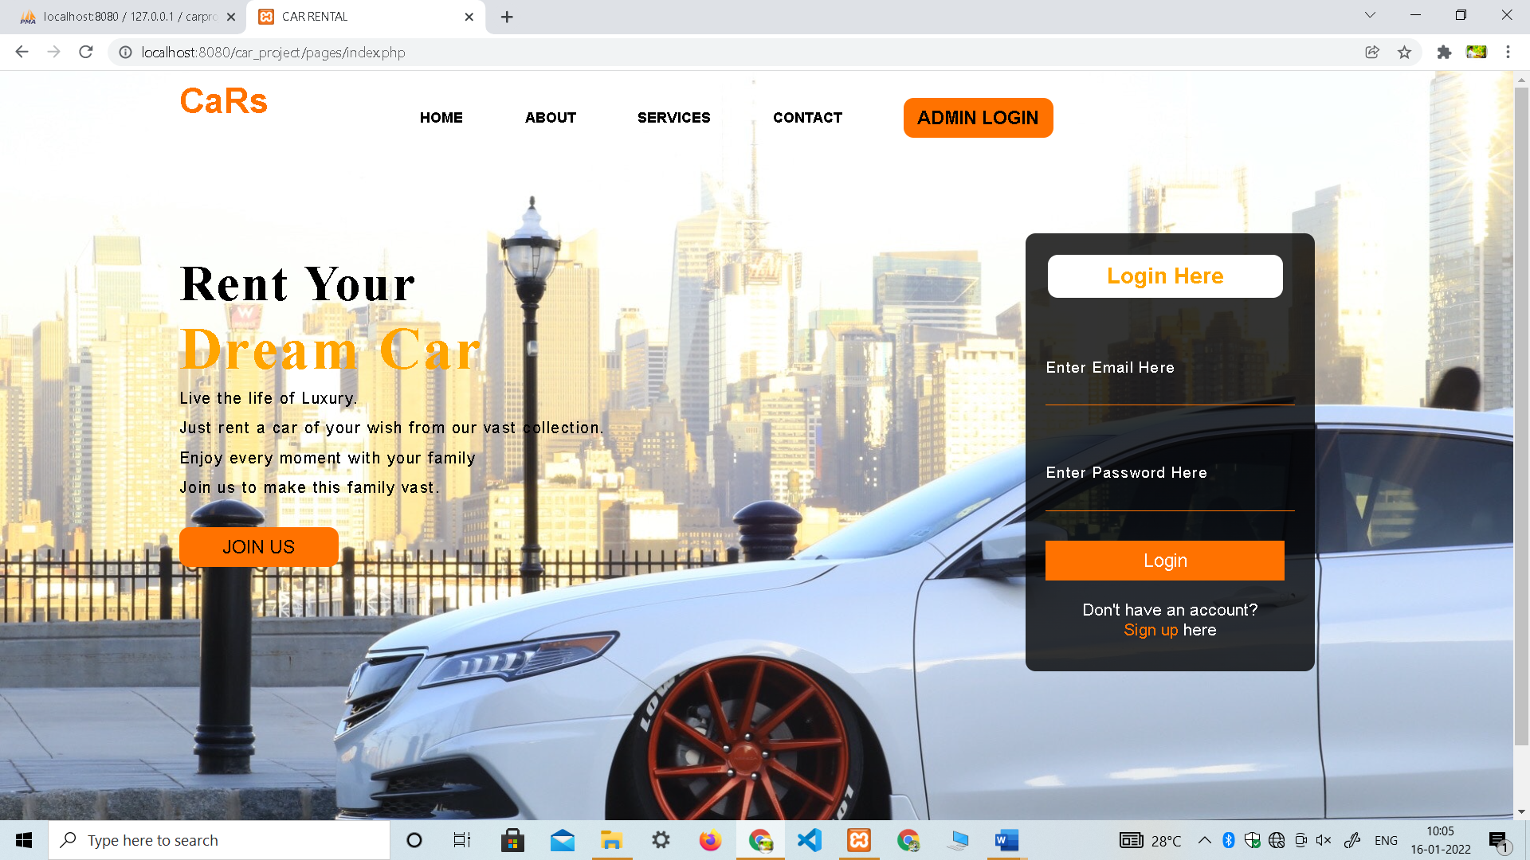Home page of our website CaRs. Here guest user can see the details of our car rental system(CaRs) and user of this website and admin can login by providing appropriate details.

**USER RESIGSTRATION**

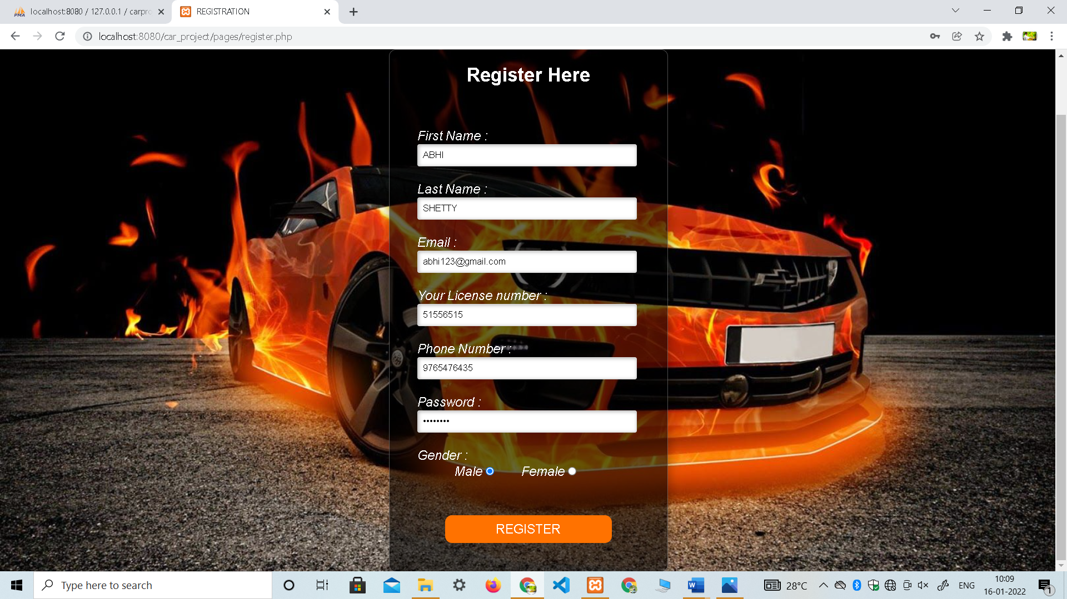

User register page where new user can register by providing valid details

**USER LOGIN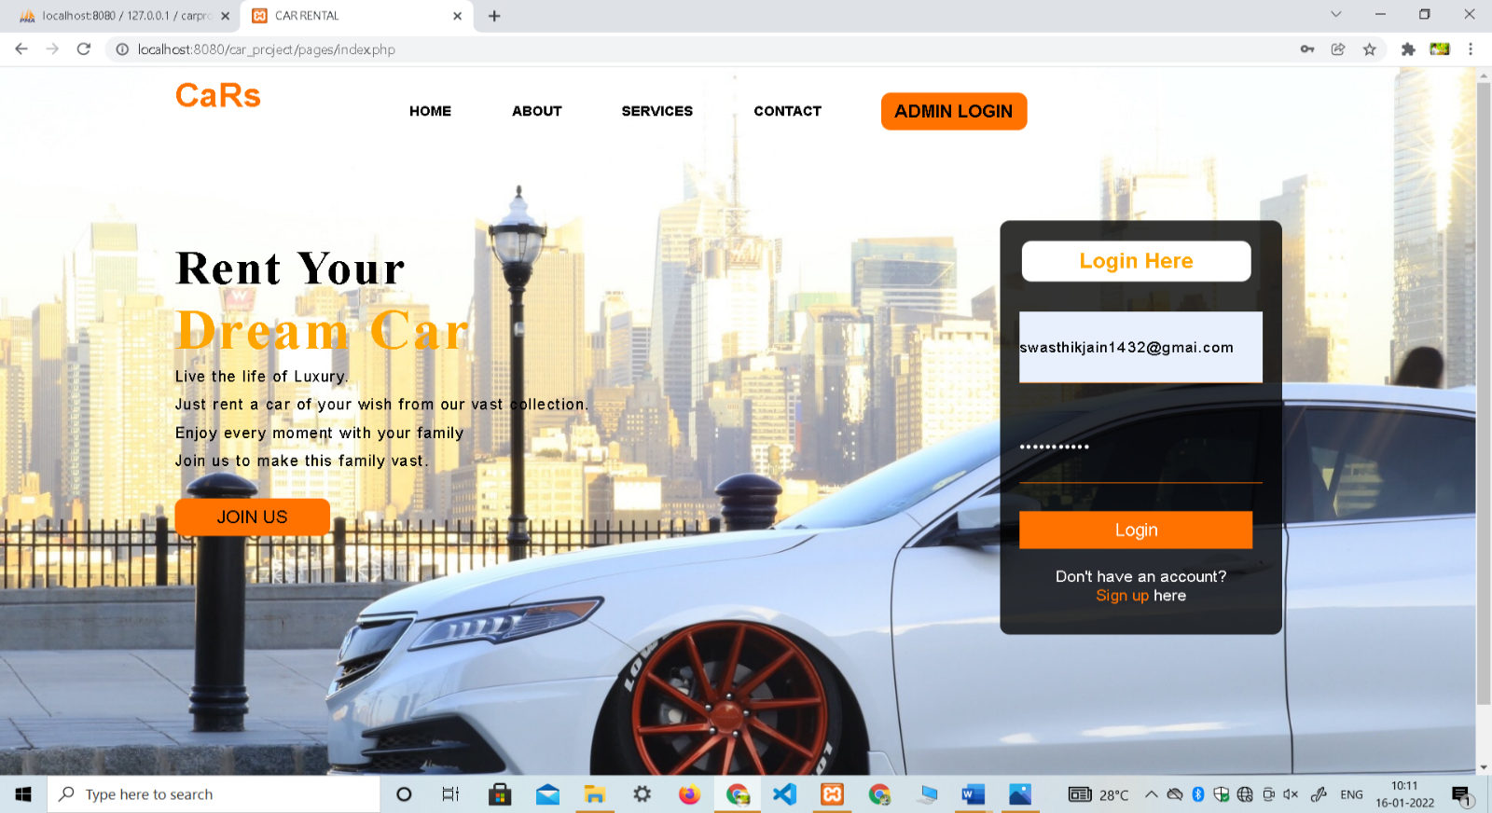L**ogin page where new user can login and can use the facilities of the website.

**VIEW CAR**

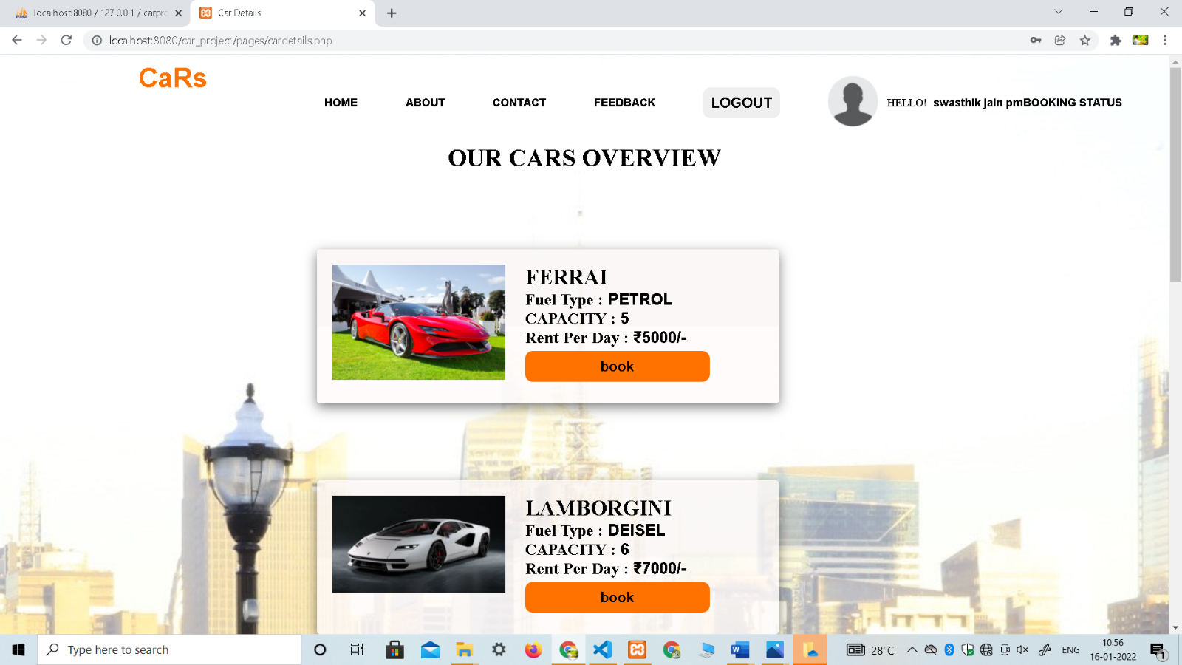

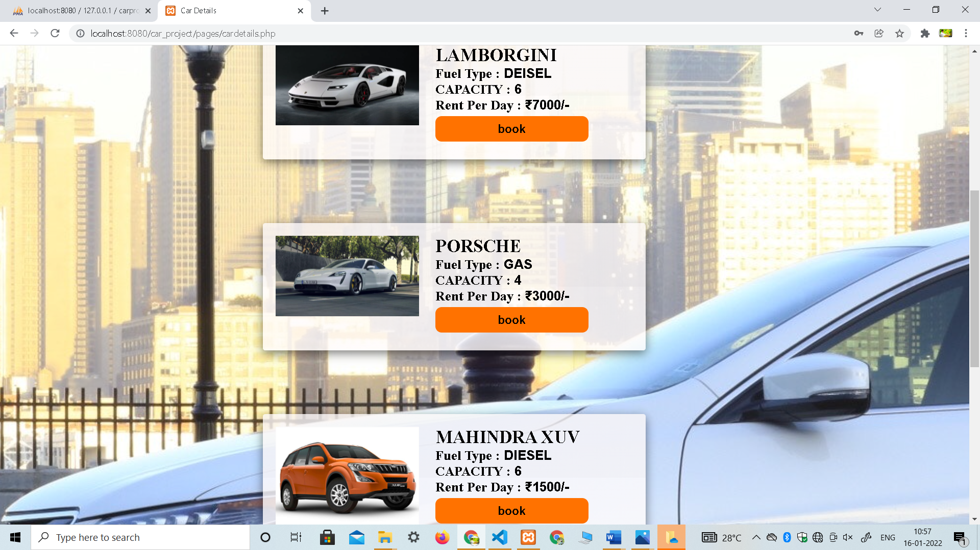Here registered user can see the available cars.

**BOOKING**

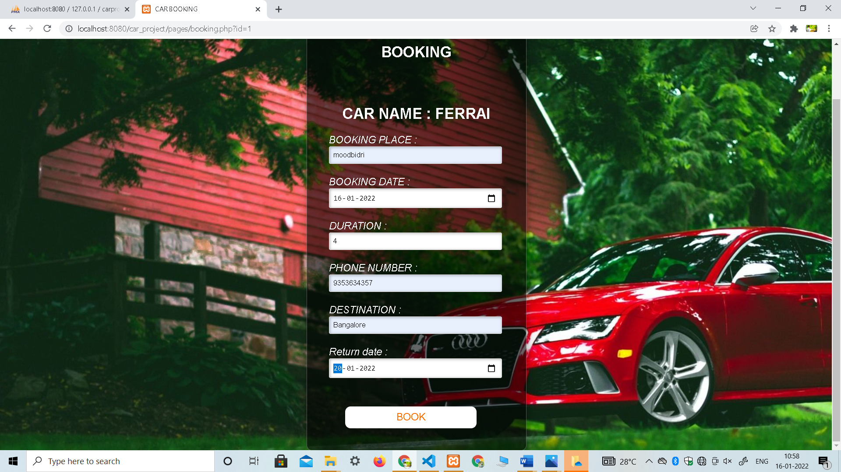

Booking page where registered user can book the car on their choice by providing valid details.

**PAYMENT**

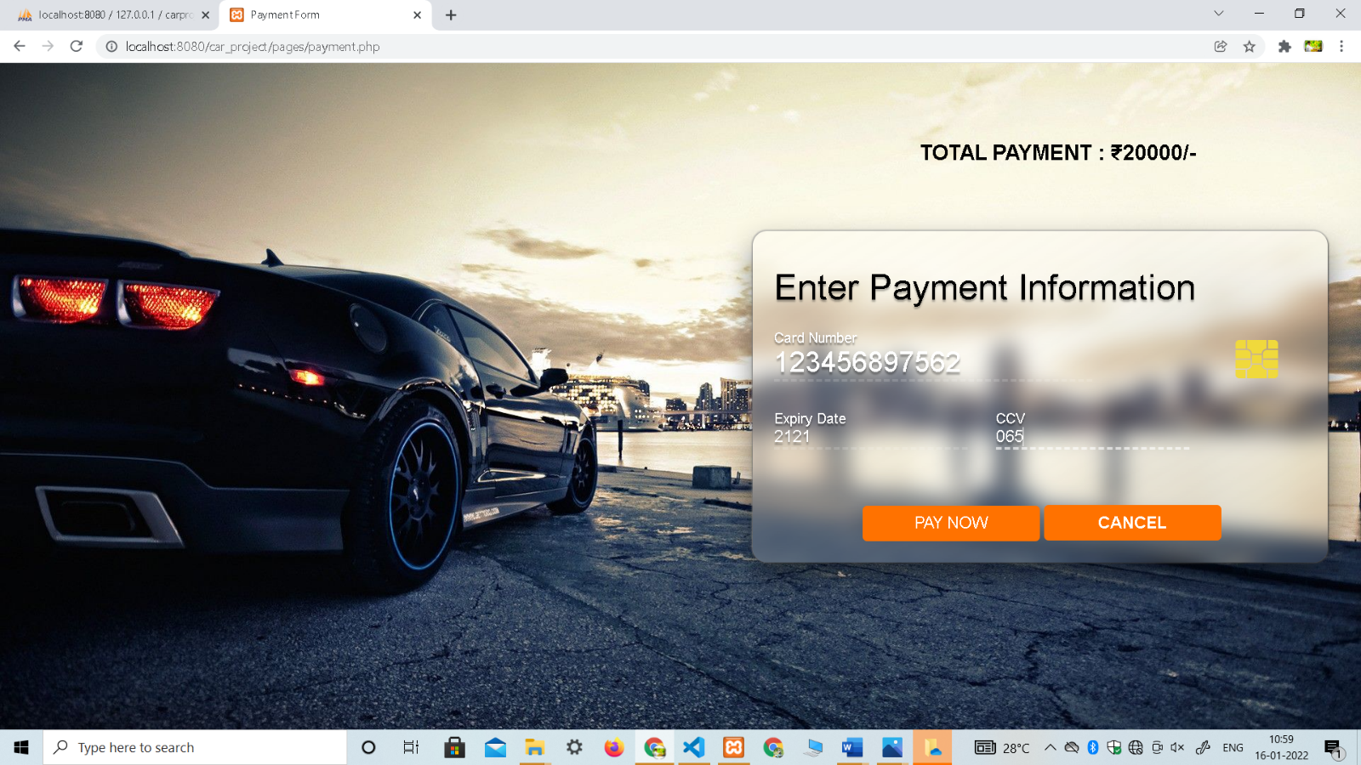Payment page where registered user can pay the payment after booing the car by providing valid details.

**PAYMENT SUCCESSFUL**

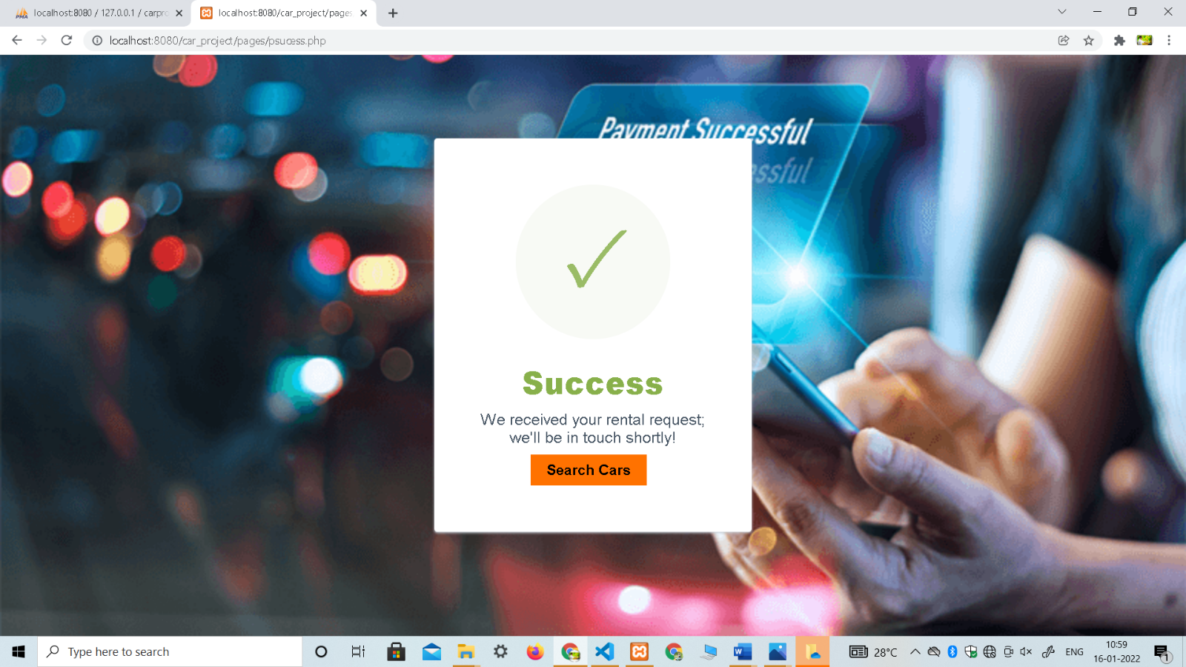 After paying the payment by providing valid information if the payment is successful it shows pop up message that payment is successful

**BOOKING STATUS**

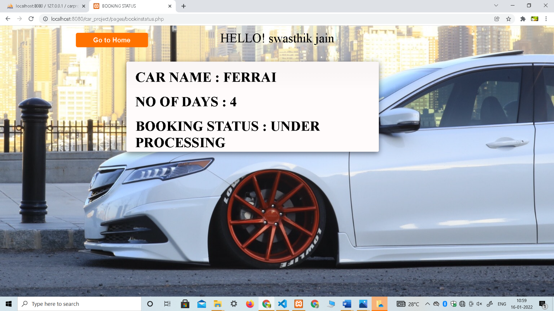Booking status page here it shows the booking status of the registered user.

**FEEDBACK**

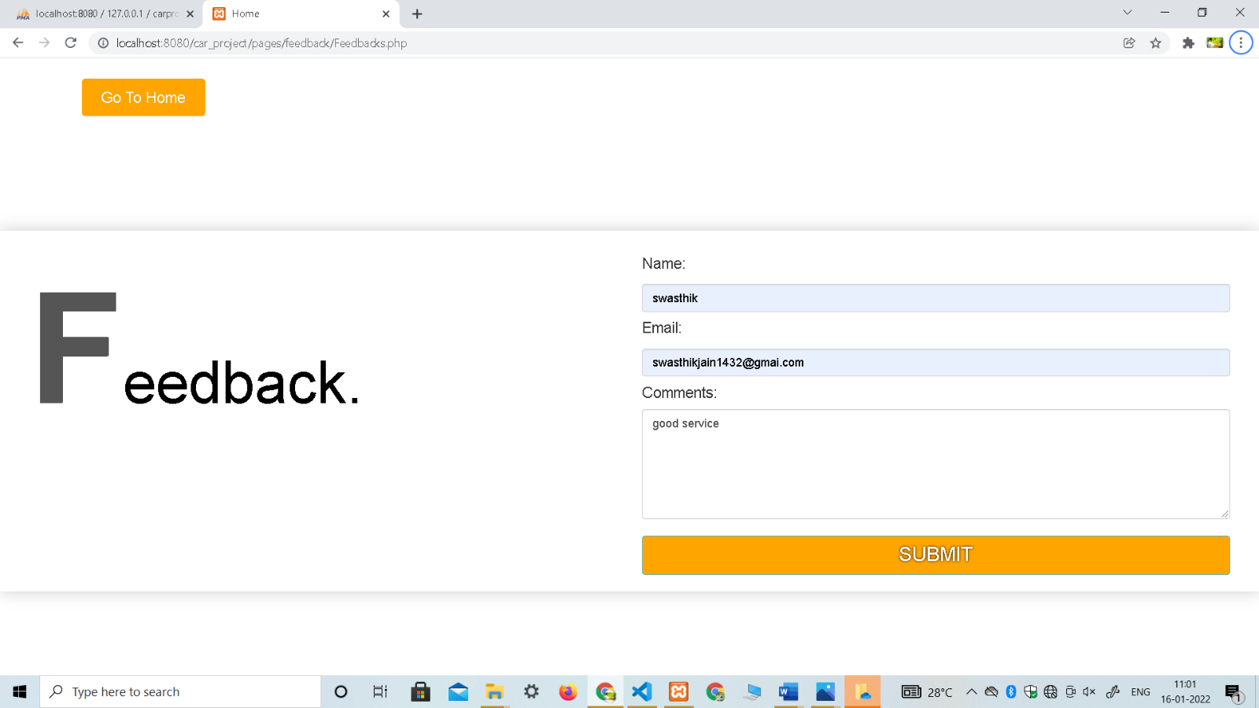

Feed back page where registered user can give their valuable feed of their experience .

**CONTACT US**

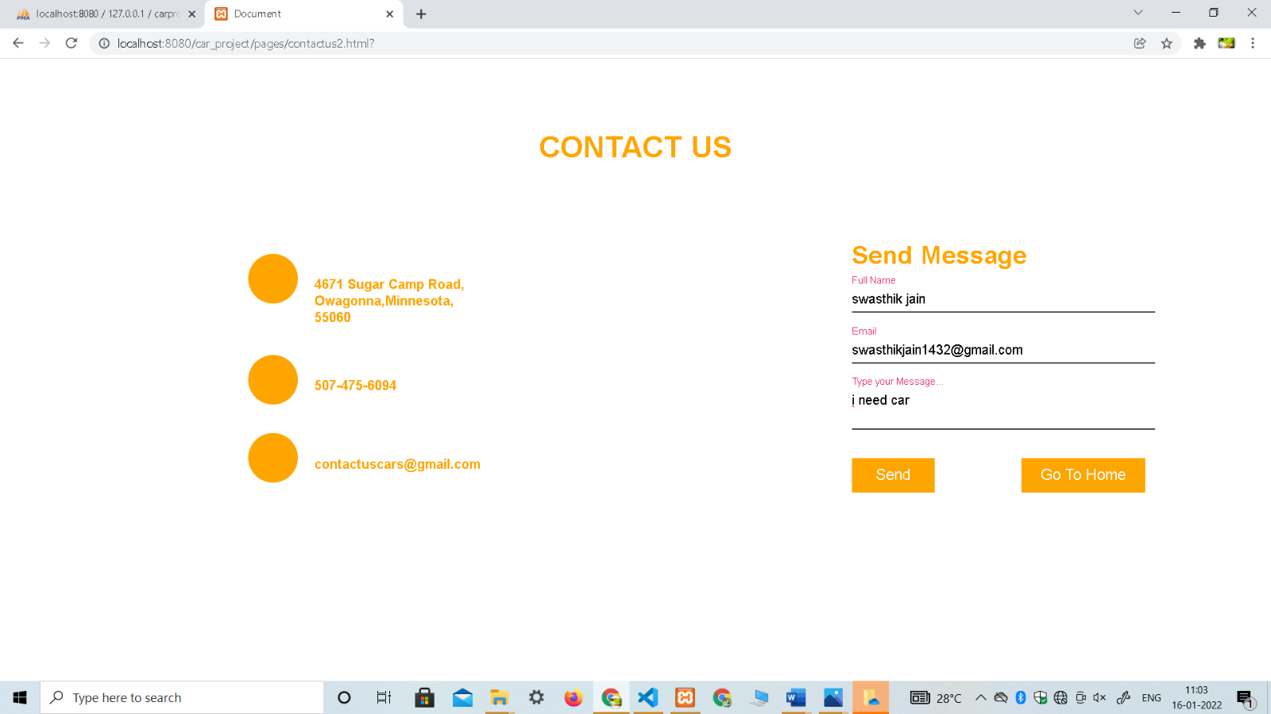

Contact us page where user can contact the company CaRs by sending message .

**ABOUT US**

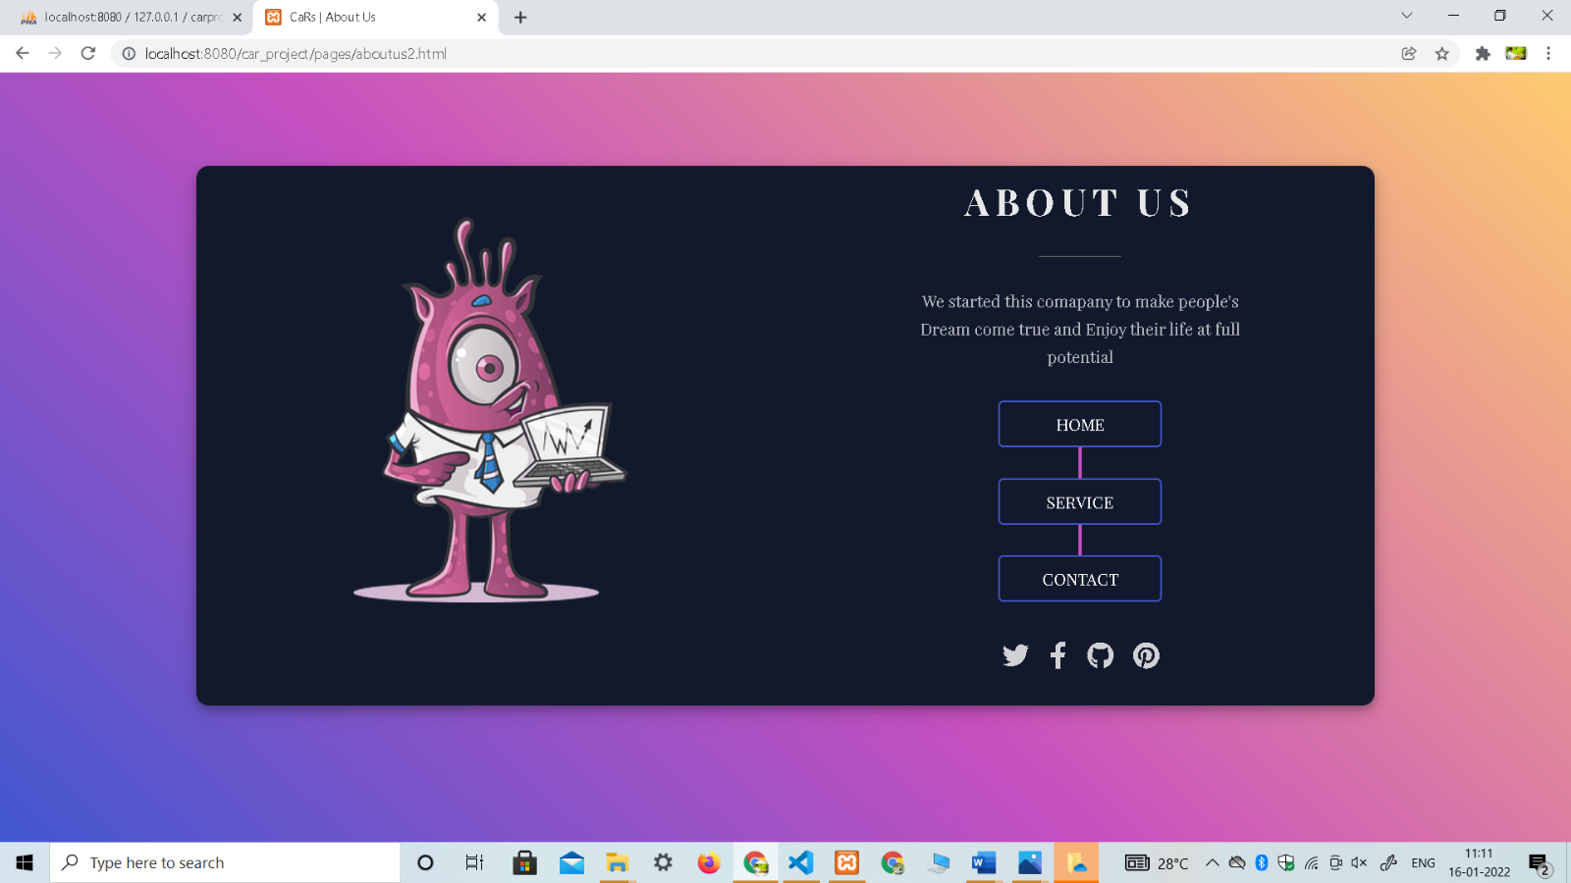About us page gives the description of the company.

**ADMIN:**

**ADMIN LOGIN**

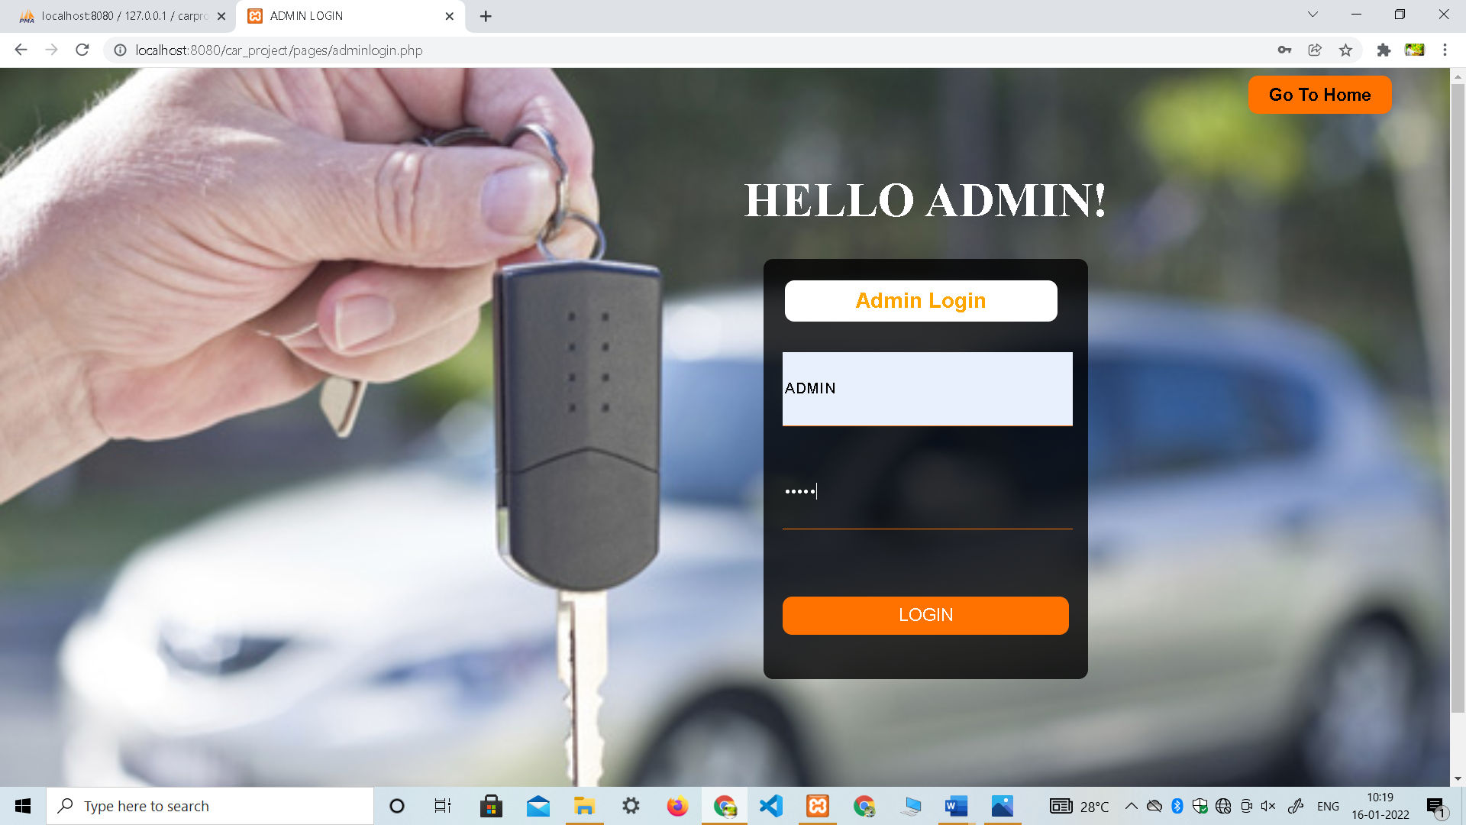

Admin login where admin can login inorder in see the progress and see the other information

**VEHICLEMANAGEMENT/DELETECAR**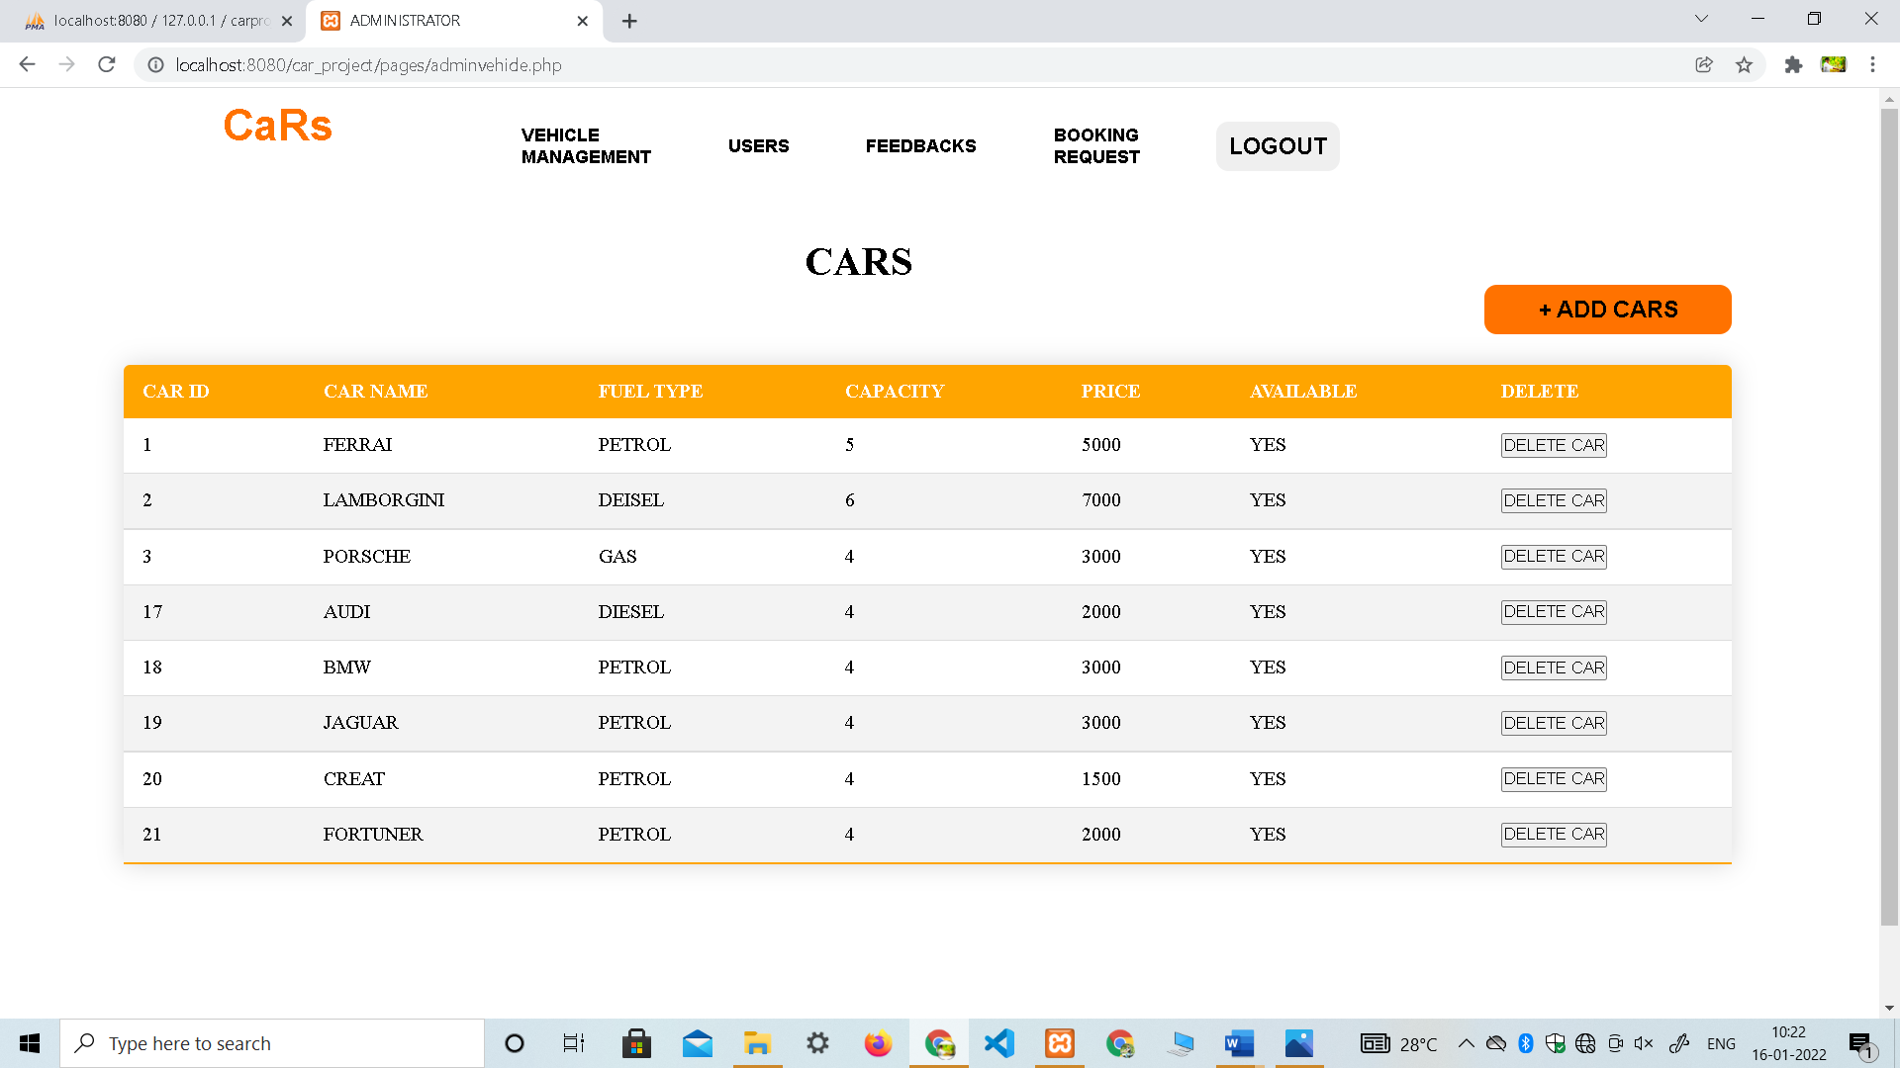

Vehicle management page where admin can see the car availability status and delete the car details .

**DELETE USER**

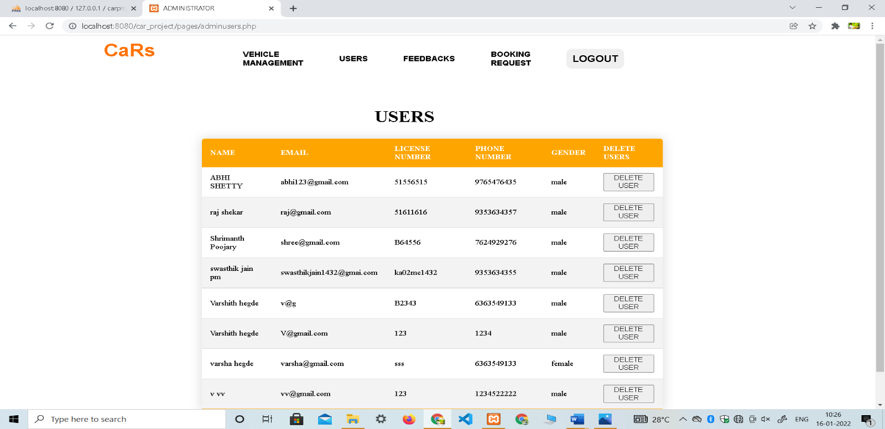

User page where admin can delete the user details.

**ADD NEW CAR**

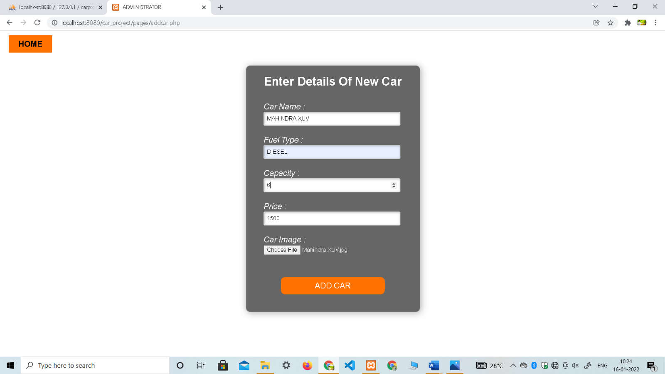Add new car page where admin can add the new car details by specifying it’s details.

**APPROVE BOOKING /CAR RETURNED STATUS**

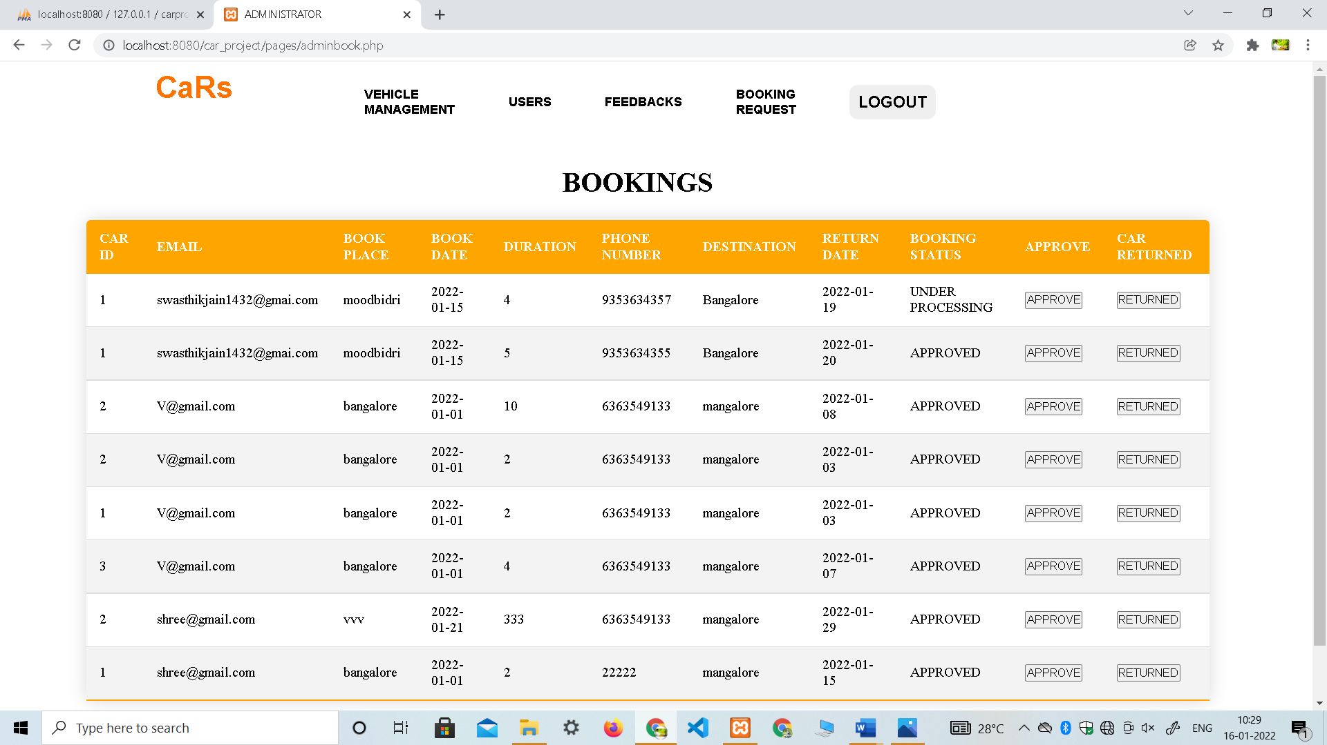Bookings page where admin can give approve to the bookings done by the user and can also check the returned status of the car.

**Chapter 7**

**CONCLUSION**

Online Car Rental Management System is user-friendly and customized software for car renting company. Online Car Rental Management System has been developed to manage and automate the overall processing of any large car renting company. Online Car Rental Management System project is capable of managing cars, booking, feedbacks, payment etc. It is a user friendly and customized software for providing support for company admin. This project is a very flexible software and it can be upgraded according to the individual needs.

**REFERENCES**

1. Fundamentals of database system, Remez elmarsri Shamkanth b 7 th edition,2017, Pearson.
2. The Joy of PHP Programming, Alan Forbes 5th edition, Plum Island.
3. <http://www.carrentingsolutions.com/>
4. <https://youtu.be/BsDoLVMnmZs>/
5. <https://www.w3schools.com/>
6. <http://www.tutorialspoint.com/>
7. <https://youtu.be/Edsxf_NBFrw/>
8. <https://youtu.be/hKB-YGF14SY/>
9. <https://youtu.be/SnPKhCdlsU/>
10. <https://youtu.be/R1djM9B0ay0>